

FarEye Serve - Training Manual

|  |  |  |  |
| --- | --- | --- | --- |
| Prepared by: | |  | |
| Reviewed by: | |  | |
| Approved by: | |  | |
|  | |  | |

# Copyright

All materials in this document are protected as the copyrights, trademarks and/or other intellectual properties owned by **FarEye**.

The copying, reproduction, use, modification or publication of any such matters or any part of the document is strictly prohibited, without our prior written permission.

# Document History

|  |  |  |
| --- | --- | --- |
| Created on | Document version | Approved by |
|  | 1.0 |  |

# Table of Contents

1. Getting Started 4

1.1. Setting up Roster 4

1.2. Add an Order 5

1.3. View Orders 10

1.4. Update Address 11

1.5. View/Assign Route 13

1.6. Manual Routing 14

1.7. Dispatch/Route Assignment 19

1.8. Driver Debrief 20

1. Getting Started

This user manual is designed for FarEye Serve and is divided into three modules i.e. model 1, model 2, and model 3. Each model is intended for different aspects of the FarEye Serve.

* The screenshots in this manual are of a specific account configured within the FarEye, so the features displayed on your account may be different depending on the data and configuration of your account.
  1. Setting up Roster

The roster is used for creating work schedules for field executives. An organization can hire part-time/full-time field executives, to complete the task as per organization's discretion.

The branch manager(s) creates a roster for every business date for their hubs and for all user types (e.g. Two Wheeler Driver or Four Wheeler Driver). The slots are allocated for orders based on the available driver’s capacity in the shift. This is a critical input to ensure that orders are not rejected due to the unavailability of vehicles.

Refer to the following steps for creating a roster:

1. Navigate to **User Management 🡪 Roster Management**.
2. Click **+Add**.  
   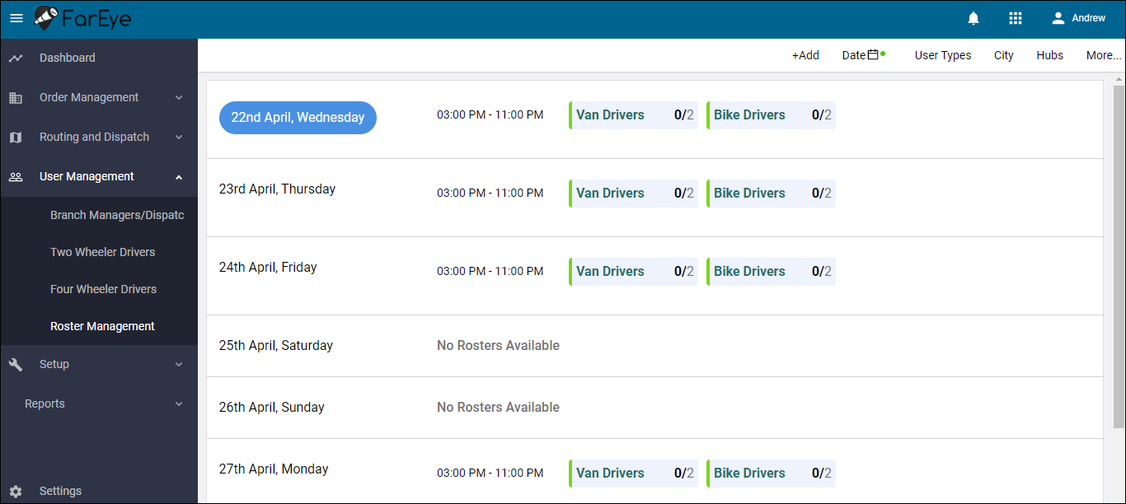
3. Fill in the form with relevant roster details. The **Requirement** field is used to define the count of the user type selected.
4. Select **Repeat** checkbox to create recurring roster. You can select Daily or Weekly roster plans to be created.   
   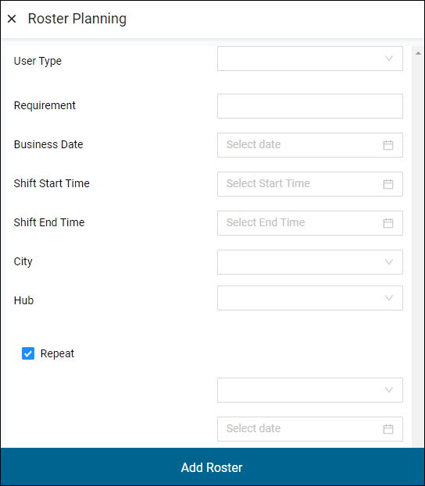
5. Click **Add Roster**.
   1. Add an Order

An order is an unassigned job which is due for completion. In FarEye, each confirmed request made by an end customer to a client is considered as an order. It remains an order until assigned to a field executive. Once assigned, it becomes a transaction.

Refer to the following steps for adding a new order:

1. Navigate to **Order Management 🡪 Active Orders.**
2. Click **+Add**.   
   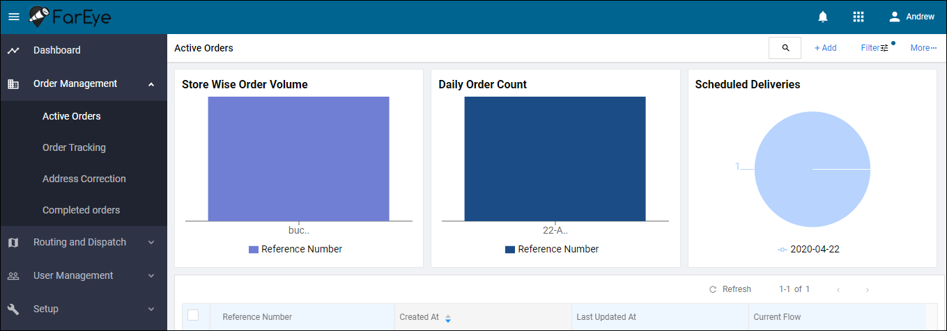
3. You can add orders using any of the following options:
   1. **Using Excel Sheet,**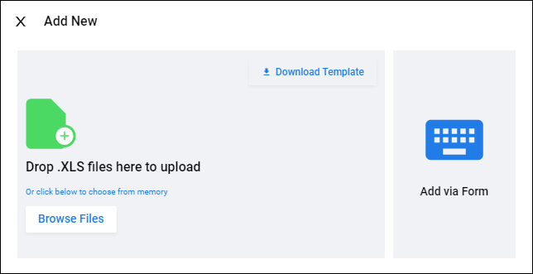
      1. Click **Download Template** to export a sample excel sheet. This sheet works as a reference for adding orders.
      2. Make the required changes to the order details in the exported sheet, but make sure that the column formats are identical to the exported template. Otherwise, the system generates error messages. Some of the common errors are:
         * Blank error
         * Already exist in database
         * Invalid file format
         * Mandatory attribute missing (e.g. city must not be null)
         * City does not exist in database

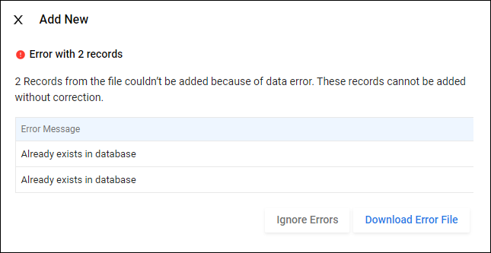

* + 1. Click **Browse Files** and upload the excel.
  1. **Using web form,**
     1. Click **Add via Form**.
     2. Fill in the form with relevant order details.  
        Note: Enter values in the fields named Start Time, End Time and Scheduled Delivery Date for model 2 and model 3.  
        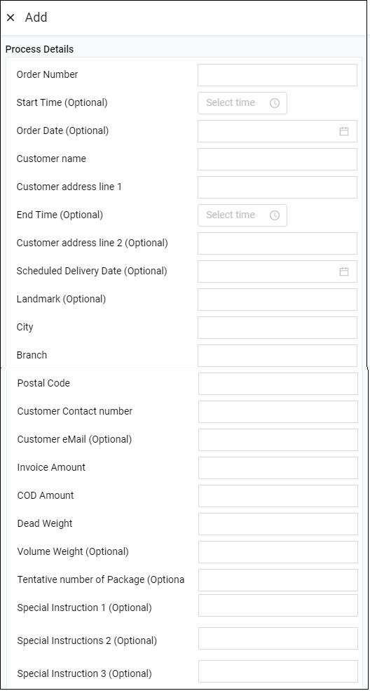  
        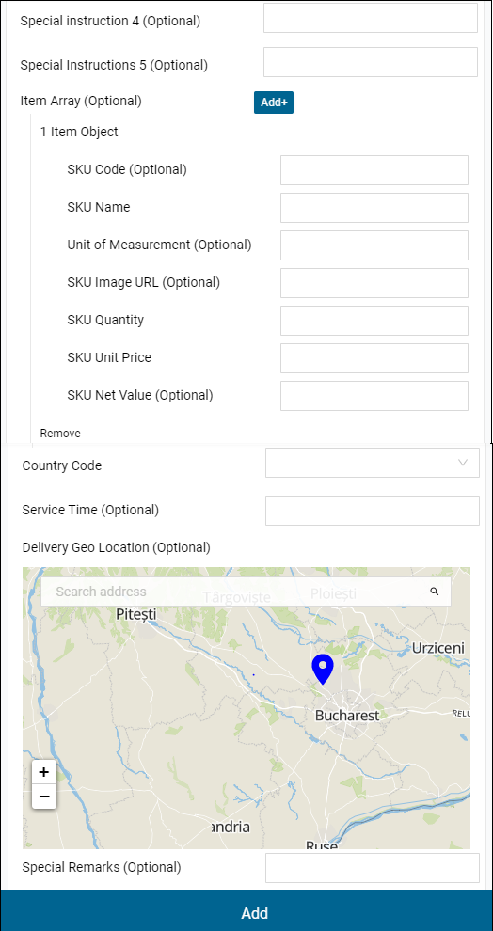
     3. Click **Add**.

A confirmation message is displayed; all the added orders appear under **Active Orders** module.

* 1. View Orders

The successfully added orders are displayed under Active Orders in graphical and tabular format. Using graph, you can view the store-wise order volume, daily order count, and scheduled deliveries. While through tabular format, you can view the details of each order, comments, and orders activities.

Refer to the following steps for viewing orders:

1. Navigate to **Order Management 🡪 Active Orders.**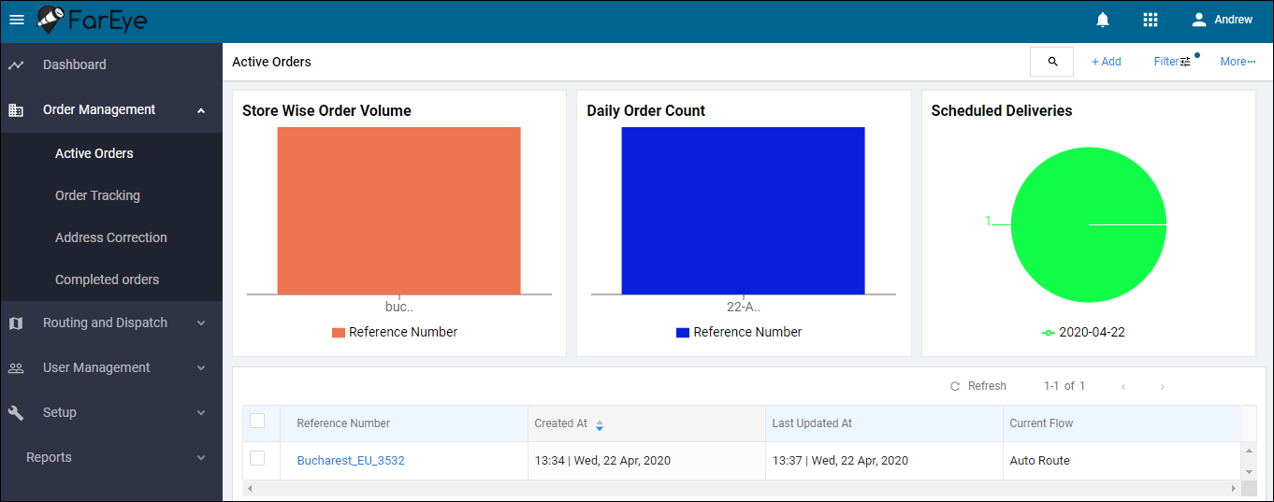
2. Click on the reference number of an order to view the order details along with their timeline and logs. The slot assigned for delivery is also visible on the Details page.  
   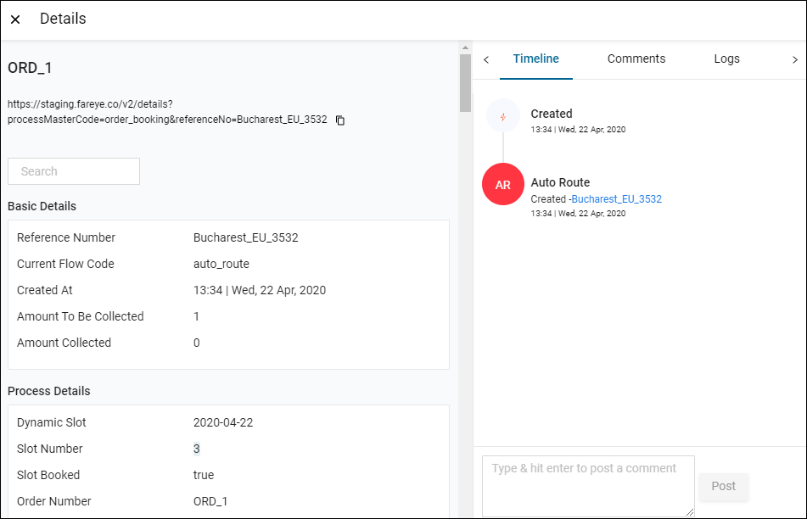
3. Once the slot is assigned, an SMS is triggered on the end customer’s phone to notify that the order has been confirmed with the respective slot number.  
   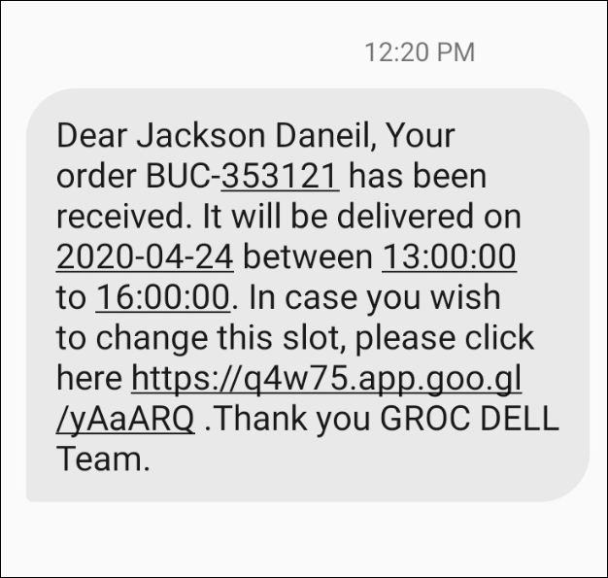
   1. Update Address

FarEye uses Google API to fetch latitude and longitude of the address to ensure that the address is correct. An order whose address details Google API is unable to fetch, is not assigned to any slot. Such orders fall under the Address Correction module.

Only the dispatcher or branch manager can update an address or can select a location on the Google map. If Google API finds that the address is correct, it fetches the address details and a slot is assigned to the order. Such orders are displayed under Active Orders.

There is also a possibility to update an address by the end customer. An SMS is sent on the customer’s mobile number including the link using which customer can update address.  
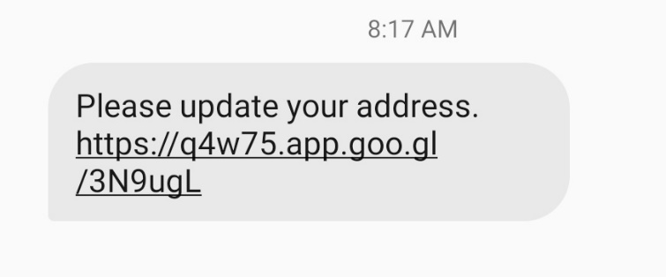

Refer to the following steps for updating an address:

1. Navigate to **Order Management > Address Correction**.
2. Select the order for which address to be updated.  
   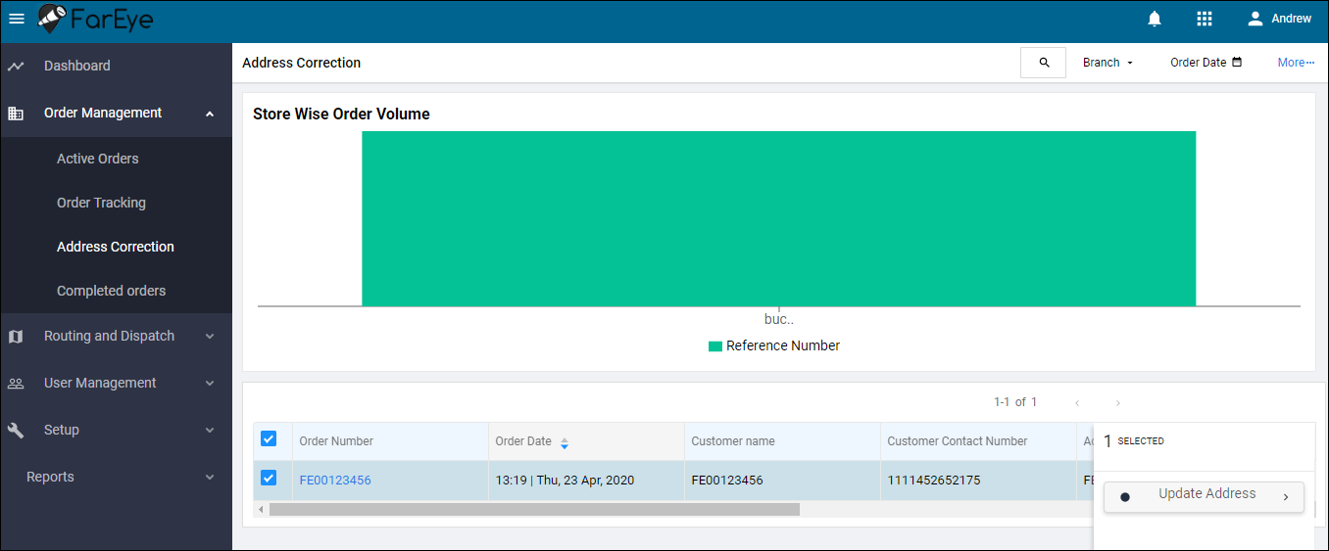
3. Click **Update Address**.  
   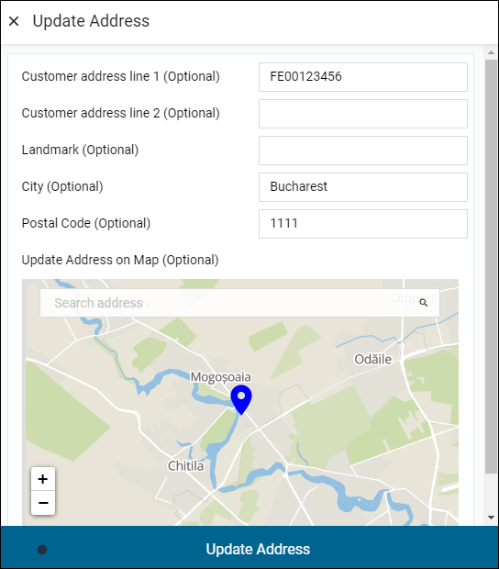
4. Enter the correct address, city, and postal code. Or, you can select location directly on map.
5. Click **Update Address** to save the changes.
   1. View/Assign Route

You can view a scheduled route and/or assign it to a field executive. If there are several scheduled routes, it becomes difficult to find out which route you want to assign to the field executive. You can filter routes based on City, Hub, and created date.

Refer to the following steps for viewing/assigning routes:

1. Navigate to **Routing and Dispatch > Scheduled Routes**.  
   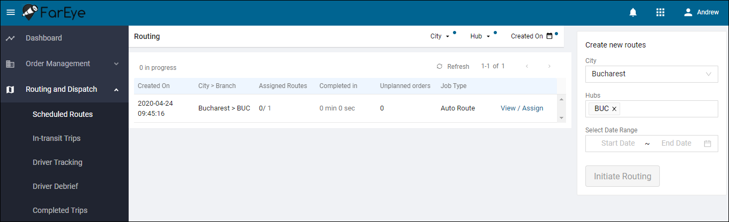
2. Click **View/Assign** corresponding to the route. It displays route details along with all the orders falling in that route. The vehicle type is either a four wheeler or two wheeler.  
   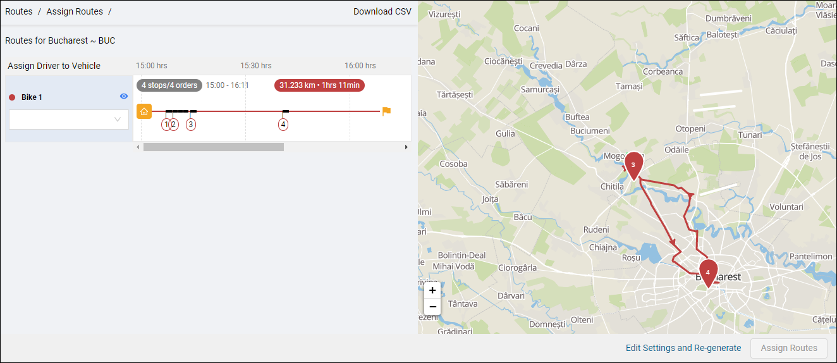
3. You can export routing details in CSV format by clicking **Download CSV**.
4. Select a driver from **Assign Driver to Vehicle** dropdown.
5. Click **Assign Routes**.
   1. Manual Routing

This routing is used when a shipment delivery date and time is defined while order booking, and the shipment is expected to be delivered on a particular date and time. There are two ways to perform manual routing, one is from Scheduled Routes and another from Active Orders.

**From Scheduled Route**

1. Navigate to **Routing and Dispatch > Scheduled Routes**.
2. Enter city, branch and date range to create a new route.  
   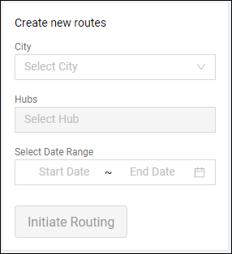
3. Click **Initiate Routing**.
4. If address is incorrect for an order on which manual routing to be performed, then Update Address gets populated to update the correct address.   
   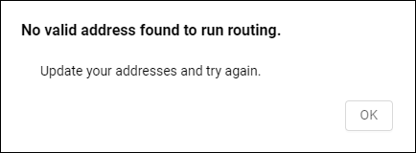  
   Whereas if the address is correct, but it is located outside the geo fence defined from the branch, then 0 address found in geo fence is displayed as shown in the below screen:  
   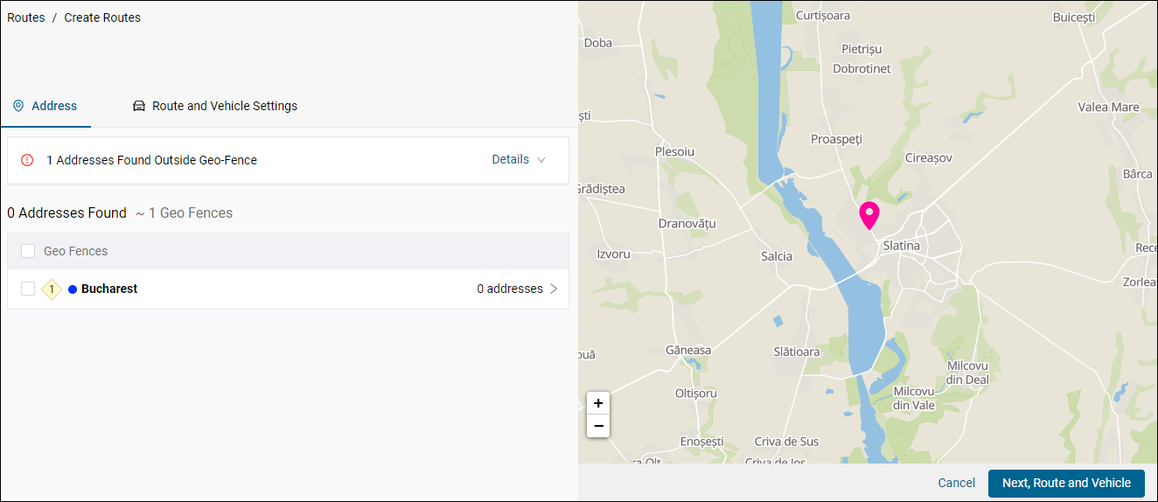  
   If the address is correct and located within geo fence, then click **Next, Route and Vehicle**.  
   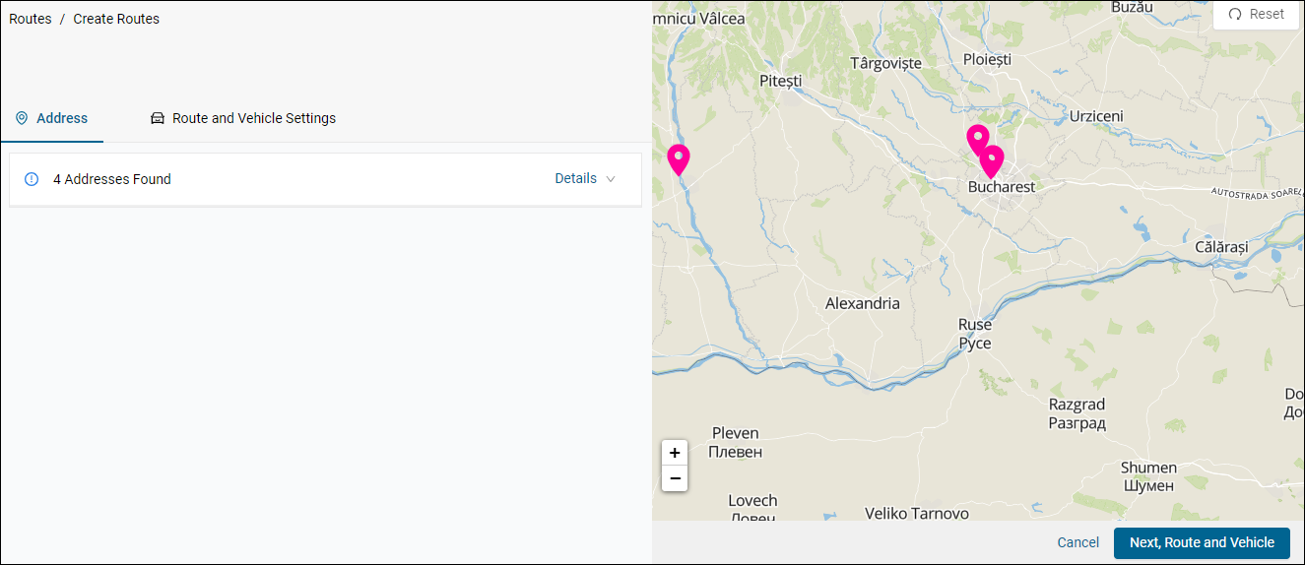
5. Configure the route and vehicle settings. Such settings are saved for the next time, so whenever you come again to create a route for the same branch, these configurations remain there; you need to enter only the number of vehicles available for a trip by default. You can make changes to the settings if required.  
   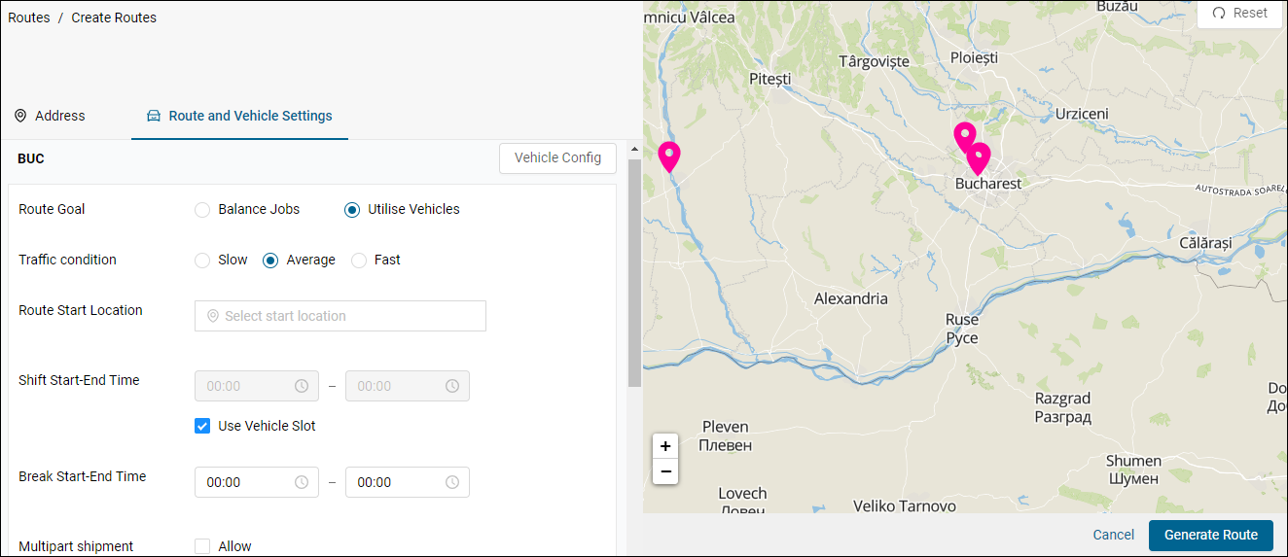  
     
   **Route Settings**
   1. **Route Goals –** Balance Jobs is distributing jobs equally among the available vehicles. Utilise Vehicles is using an adequate number of vehicles to complete jobs of the assigned route; it helps to avoid unnecessary expense.
   2. **Traffic Condition –** Based on traffic prediction, experience and holiday master, manager selects a traffic conditions for the route. In case of slow or fast traffic condition, you need to define a variation in percentage (%). This shows that the traffic might be expected slower or faster on the route on the selected delivery date.
   3. **Route Start Location** – The starting location for the route from where the vehicle will start. This is often a hub location.
   4. **Shift Start-End Time** – The start and end time of shift for field executives who will perform delivery. If you select the vehicle slot checkbox, then shift start and end time will be displayed according to slots defined in the Vehicle Config.
   5. **Break Start-End Time** – The break start and end time for field executives.
   6. **Multipart Shipment** – Select checkbox to allow multipart shipments during the route.
   7. **Return to Hub** – If vehicles should be returned to the hub location, select Allowed. Else, select Not Allow.
   8. **Service Time –** Total time allowed for a driver to spend at the end customer’s location while delivering parcels. It is considered in minutes.
   9. Select a mode of vehicle from Driving, Bicycle, or Walk. The mode selected from here (Route Settings) is by default selected on the Vehicle Settings page.
   10. Enter the number of vehicles available for the trip.

**Vehicle Settings**Click **Vehicle Config** to add more vehicles or to view the existing vehicles available for the selected address.  
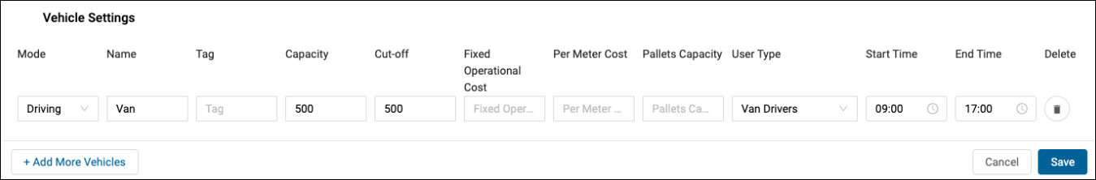

1. Click **Add More Vehicles** to add vehicle details.
2. Tag is used for the identification purpose so that the system can recognize vehicles by their tags.
3. Capacity is the total weight the vehicle can carry.
4. Cut-off is the maximum weight/volume of a packet assigned to the vehicle.
5. Operational cost is a fixed cost for the vehicle. It may vary depending on which vehicle type is selected.
6. Per Meter Cost is a variable cost dependent on the number of meters a vehicle being driven.
7. Click **Save**.
8. Once the route and vehicle configurations are done, click **Generate Route**.

**From Active Orders**

1. Go to **Order Management > Active Orders**.
2. Select an order to perform manual routing.  
   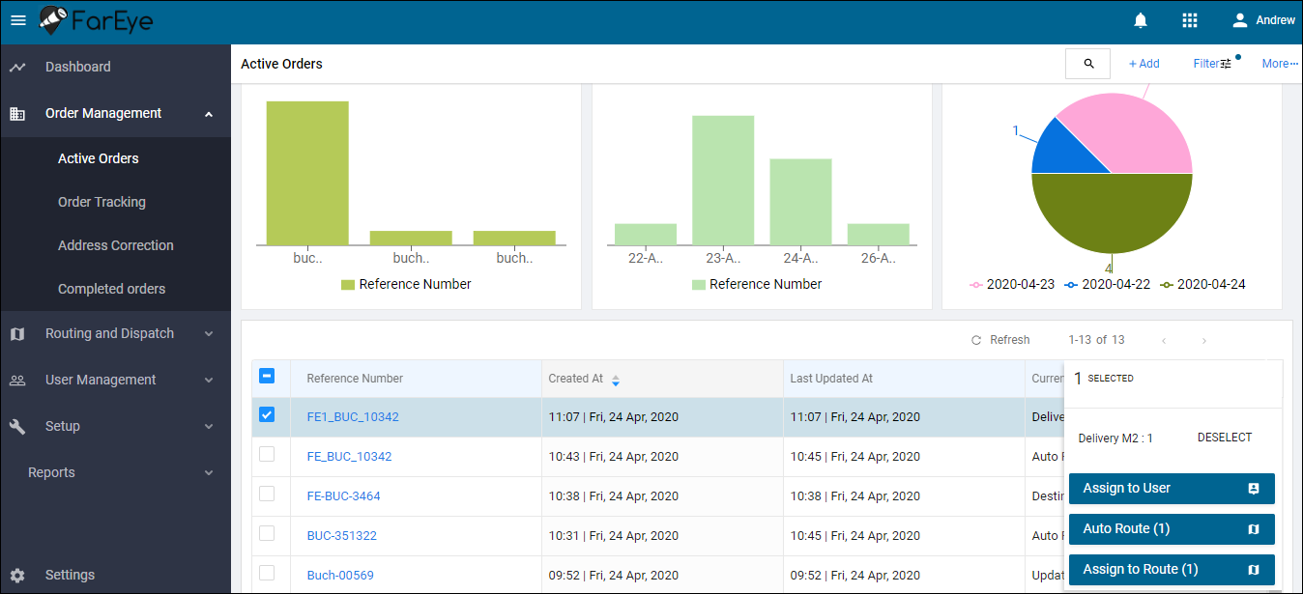
3. Click **Auto Route**.  
   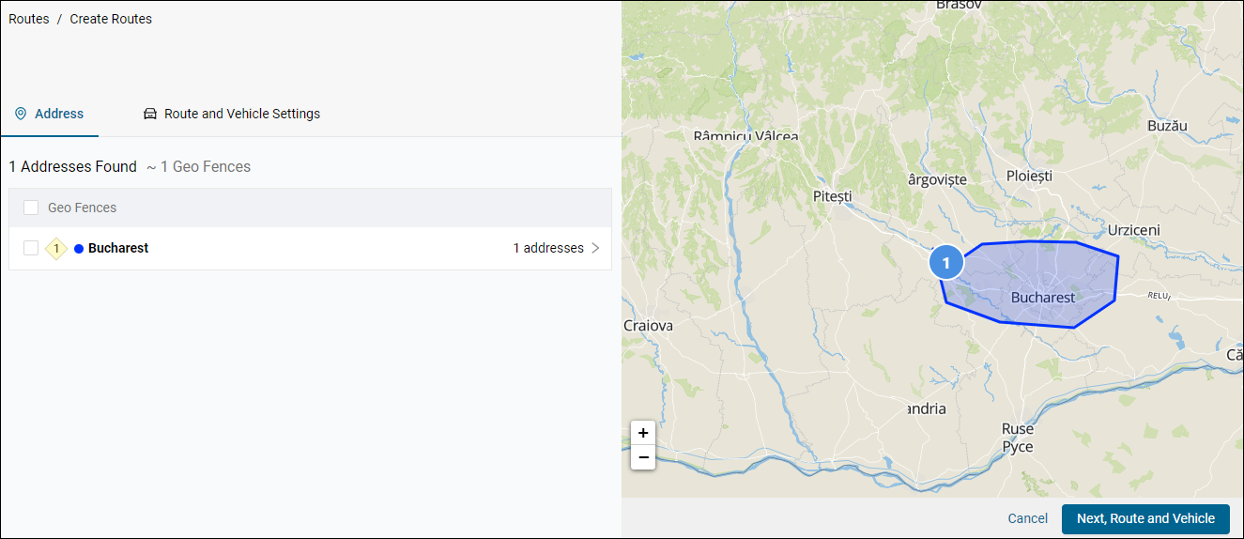
4. Refer to the steps from 5 to 6 of **Manual Routing from Scheduled Route** for route and vehicle configuration.
   1. Dispatch/Route Assignment

Once the route is scheduled for an order, it is assigned to a field executive to perform delivery of the shipment to the end user. Route can be assigned to a field executive of the same branch only.

Refer to the following steps for route assignment:

1. Navigate to **Routing and** **Dispatch > Scheduled Routes**.
2. Click **View/Assign** against the route to be assigned.  
   
3. Select a field executive from **Assign Driver to Vehicle** dropdown.  
   
4. Click **Assign Routes**.
   1. Driver Debrief

The debrief is used to reconcile parcels, and cash is collected from the field executive when returned to the hub.

The option is activated only after the field executive marks End Trip on FarEye mobile app. Irrespective of whether the vehicle is returned or not returned to the hub, the field executive must mark the trip as END Trip, then only trip details will display under the Driver Debrief module. The manager can complete this activity after the shift end time and can validate the field executive’s activities.

Refer to the following steps for driver debrief:

1. Navigate to **Routing and Dispatch > Driver Debrief**.  
   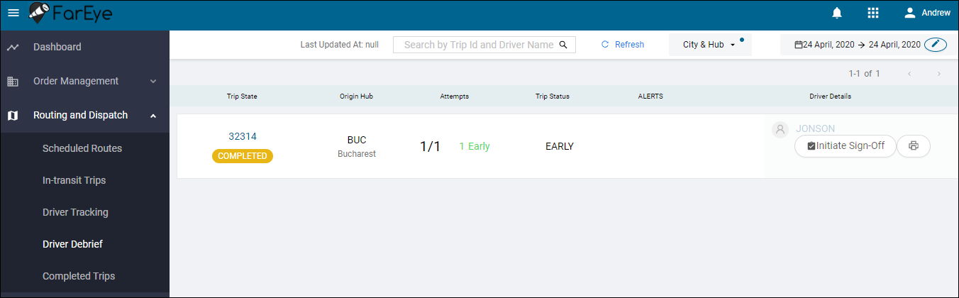
2. Click **Initiate Sign Off**.
3. Validate the transaction summary, and click **Manager Sign Off**.  
   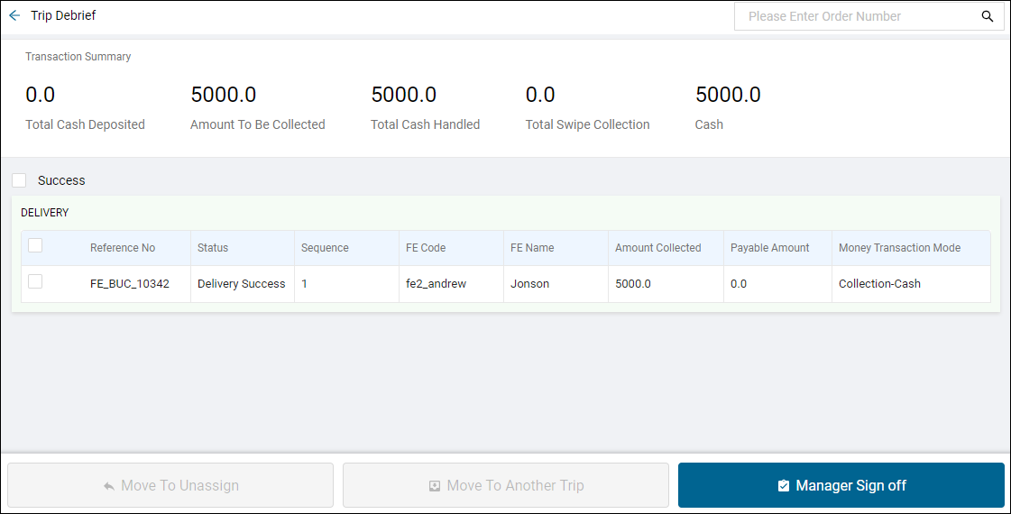
4. This activity marks the completion of the trip.